Types of UML Diagrams:
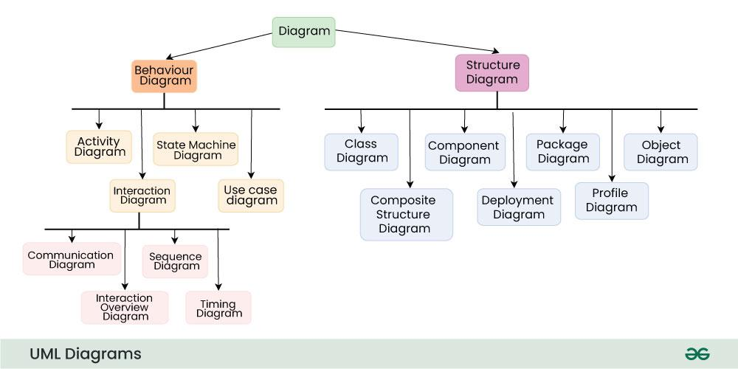

Structural UML Diagrams :
class diagram: It is the building block of all object-oriented software systems. We use class diagrams to depict the static structure of a system by showing system's classes, their methods and attributes.
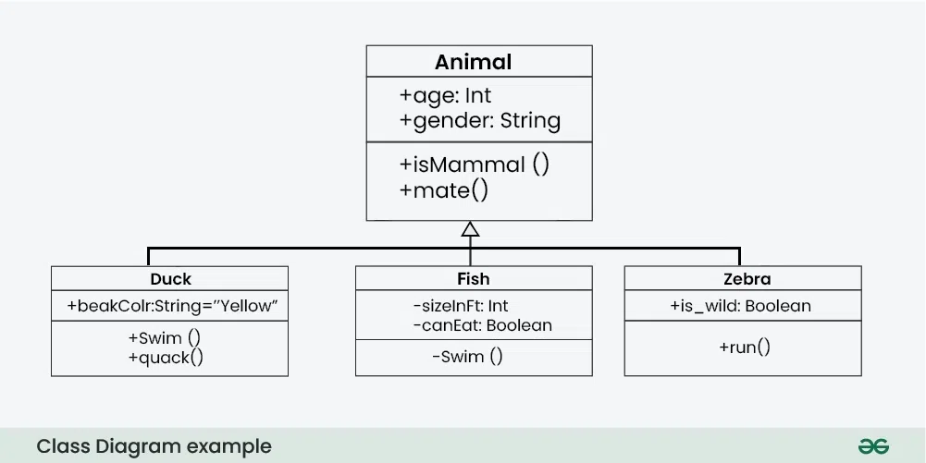
Object Diagram: Can be referred to as a screenshot of the instances in a system and the relationship that exists between them

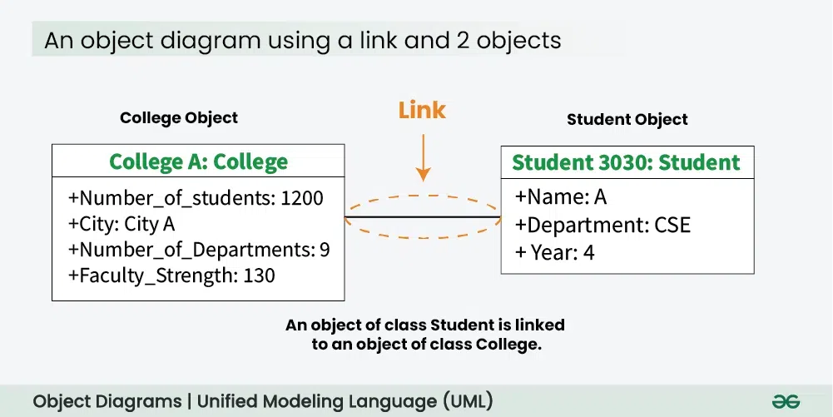

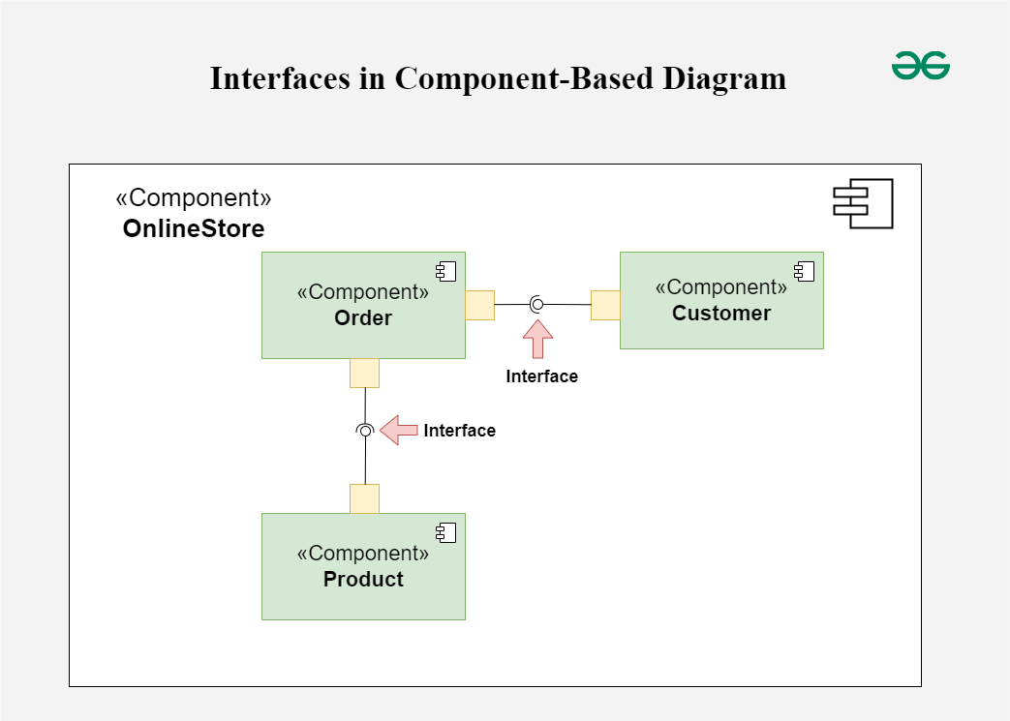
Component diagram: Represent how physical components in system

have been organized.system have been organized.

- Deployment Diagrams: Represent system hardware and its software.
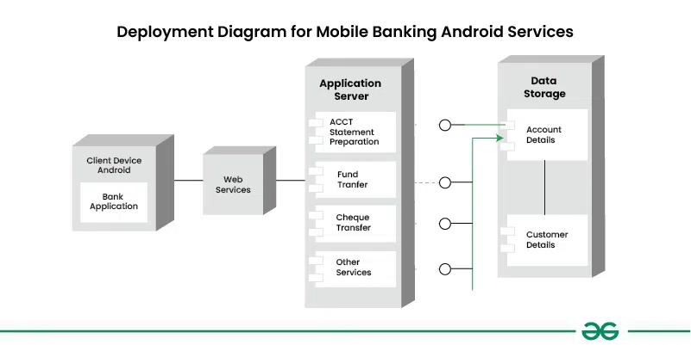

Package Diagrams: Depict how packages and their elements have been organized. Primarily used to organise class and use case diagrams.

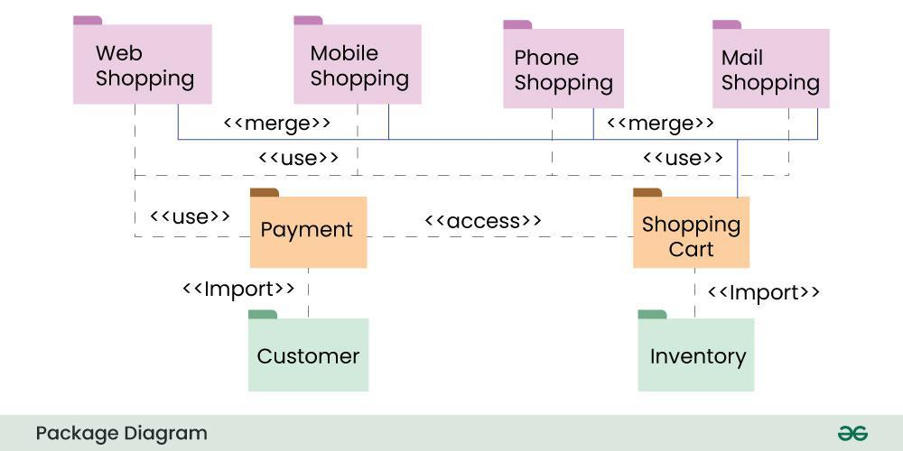

Behavioral UML Diagrams:
state diagram: Represent the condition or part of the system.
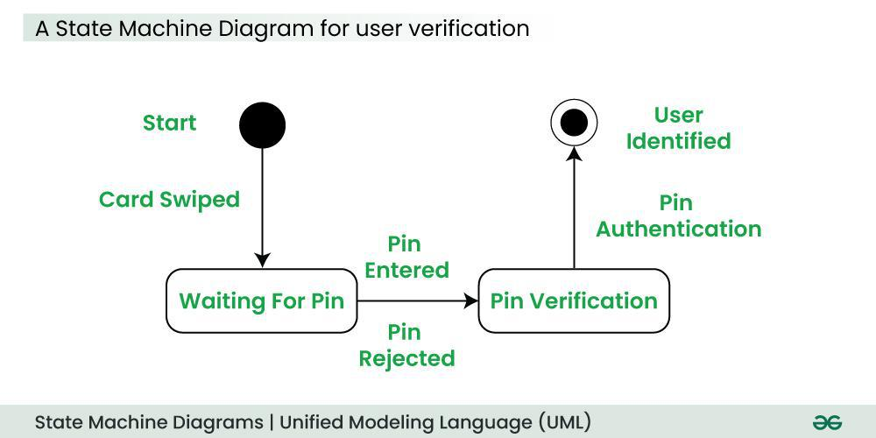

Activity Diagrams: Flow of control in a system.
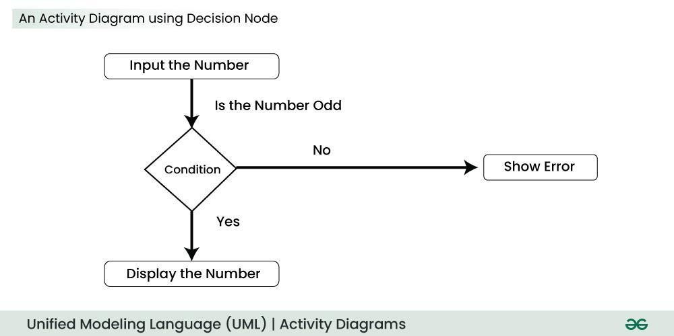
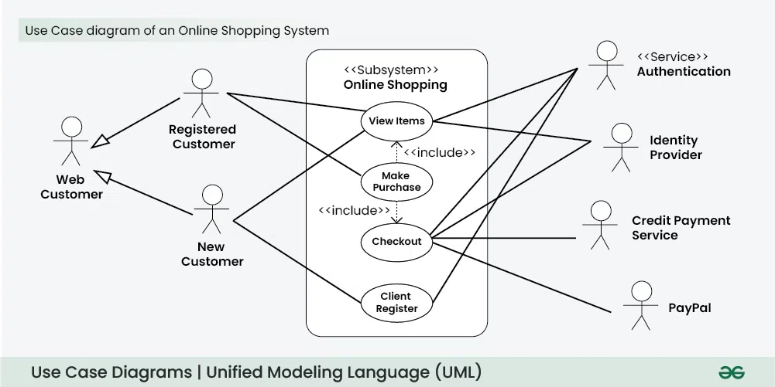
Use Case Diagrams: Depict the functionality or a part of a system.

Sequence diagram: Interaction between objects in a sequential order.
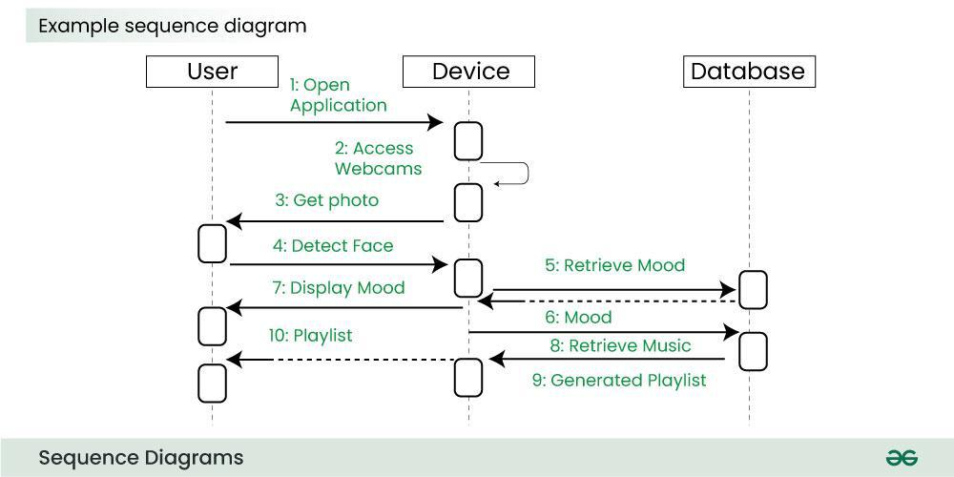

Communication Diagram: Sequenced messages exchanged b/w objects.
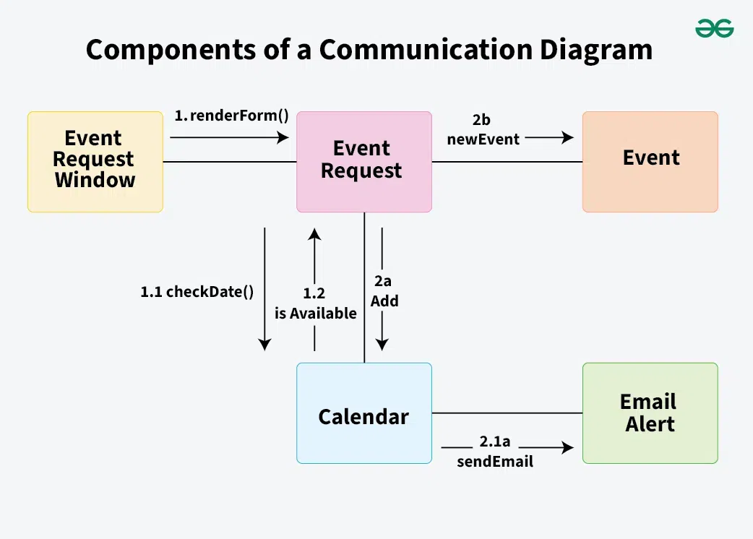

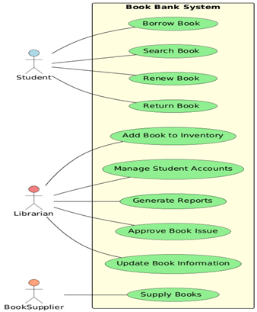
c.Book Bank System:

Use-Case Diagram:
Use Case Diagrams are used to depict the functionality of a system or a part of a system. They are widely used to illustrate the functional requirements of the system and its interaction with external agents(actors).

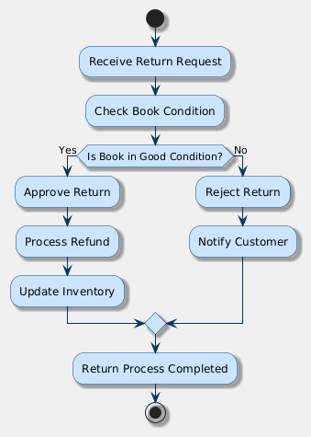

Activity Diagram:
Activity diagrams are graphical representations of workflows of step wise activities and actions with support for choice, iteration and concurrency.
An activity diagram shows the overall flow of control. An activity is shown as an rounded box containing the name of the operation.

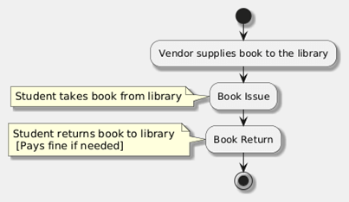
State Chart Diagram:
It consists of state, events and activities.

.
Class Diagram: The class diagram, also referred to as object modeling is the main static analysis diagram.
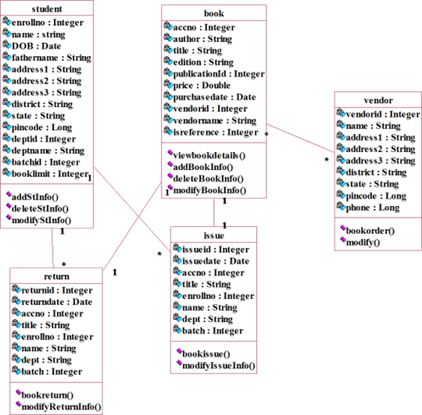

Component Diagram: Deployment diagrams are used to visualize the topology of the physical components of a system where the software components are deployed.
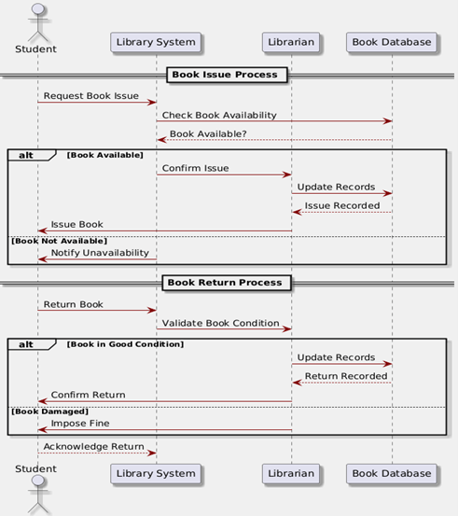

Sequence Diagram: Sequence and interactions of a given USE- CASE or scenario. Sequence diagrams can capture most of the information about the system.
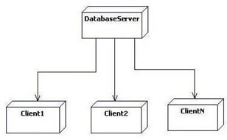

b. Online Exam Registration System:

Use case diagram:
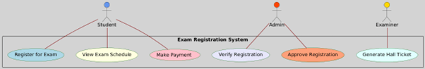

Activity diagram:
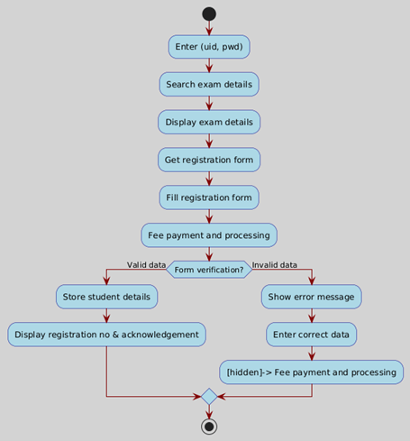

Class diagram:
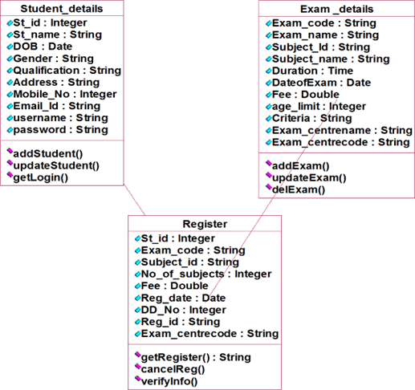

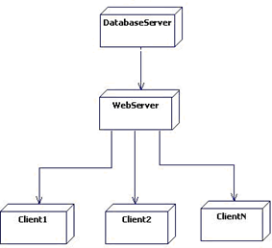
Deployment diagram:
Used to visualize the topology
of the physical components.

Interaction diagram:
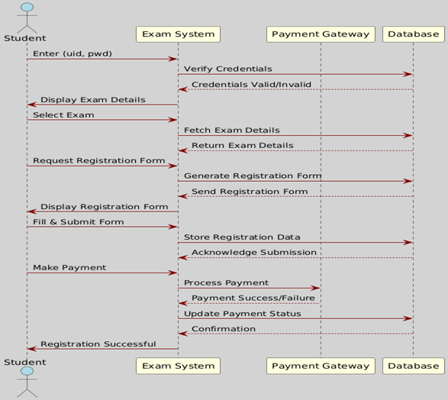

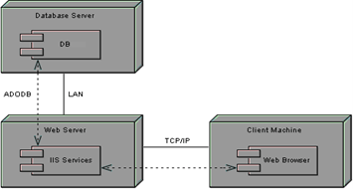
Component diagram:
Visualize the organization and relationships among components in a system.

